Module Name: Login page
Test Case ID: 1
Webpage URL: https://practicetestautomation.com/practice-test-login/

Scenario ID: 1
Scenario: Sign up with valid credential (valid ID, Password)
Test Steps:
1. Open login page
2. Enter username
3. Enter a Password
4. Click on login button

Screenshots:
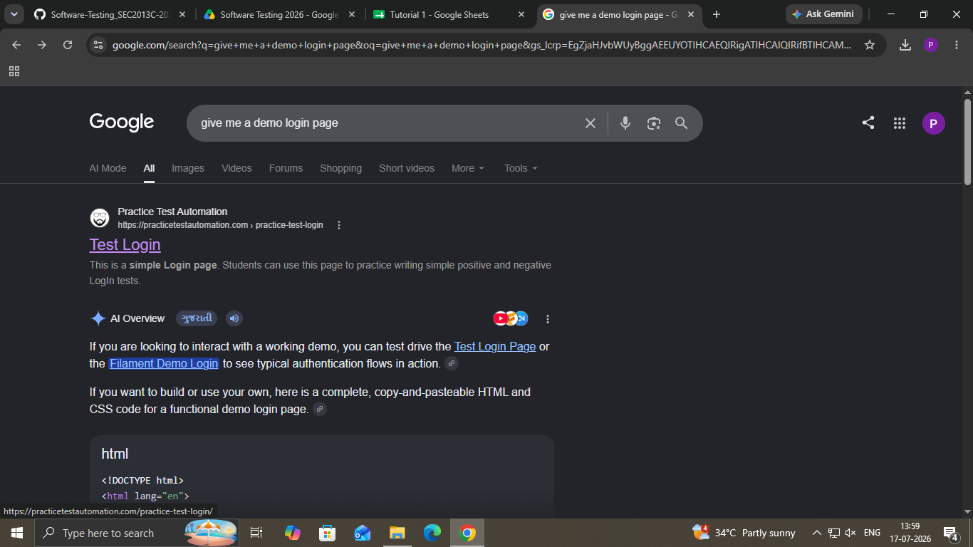
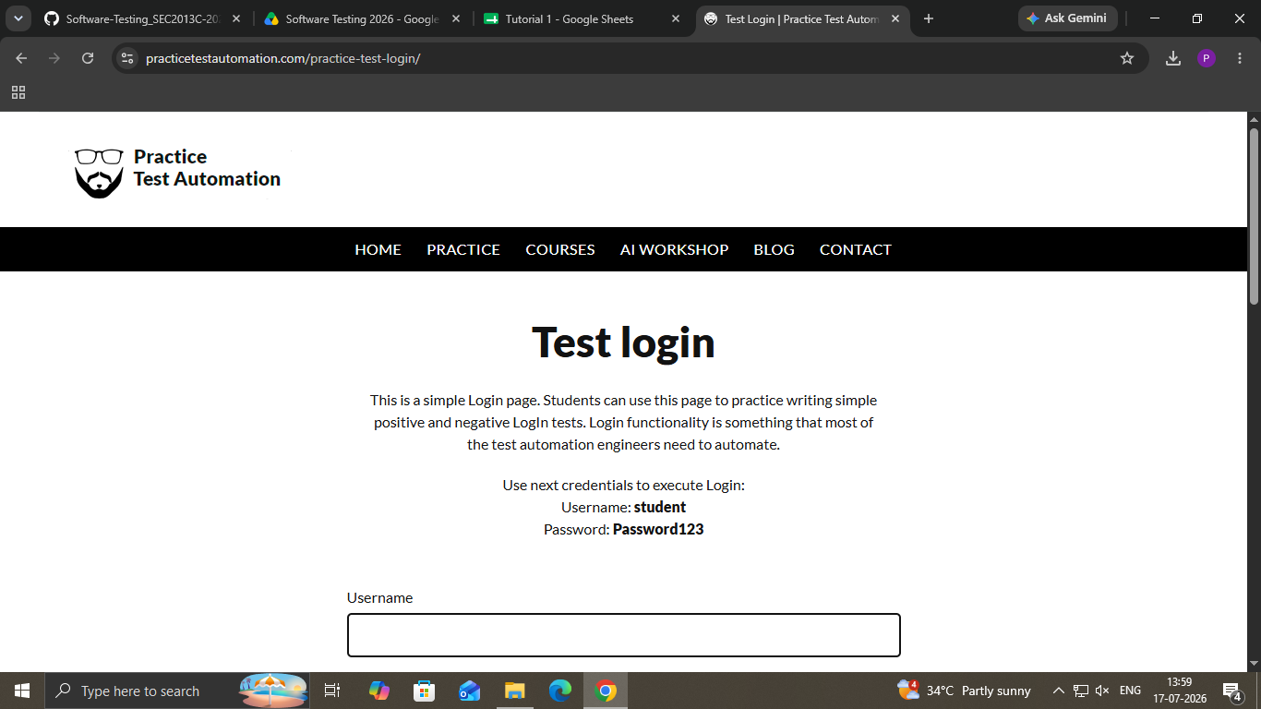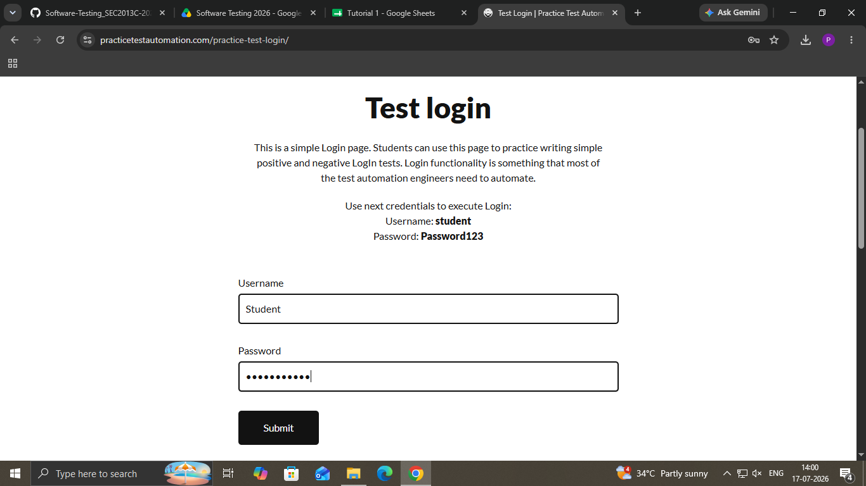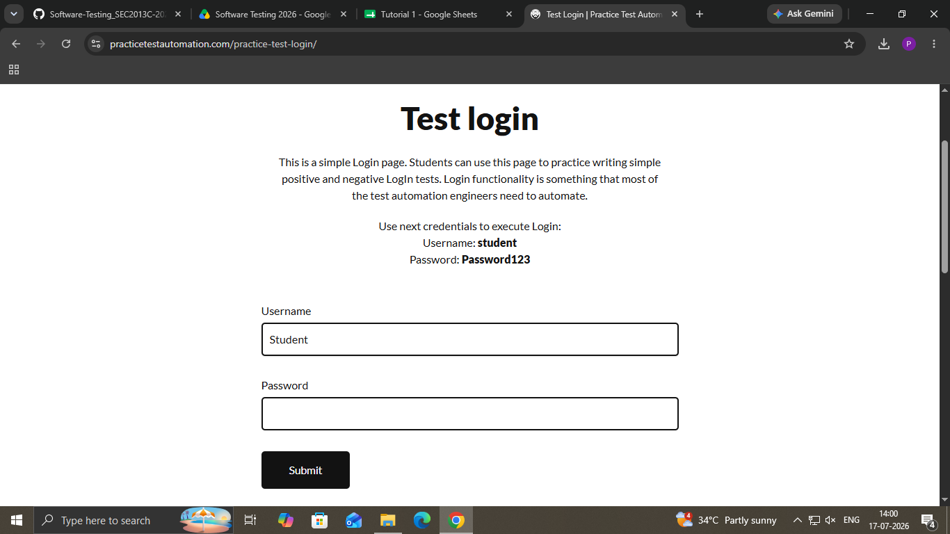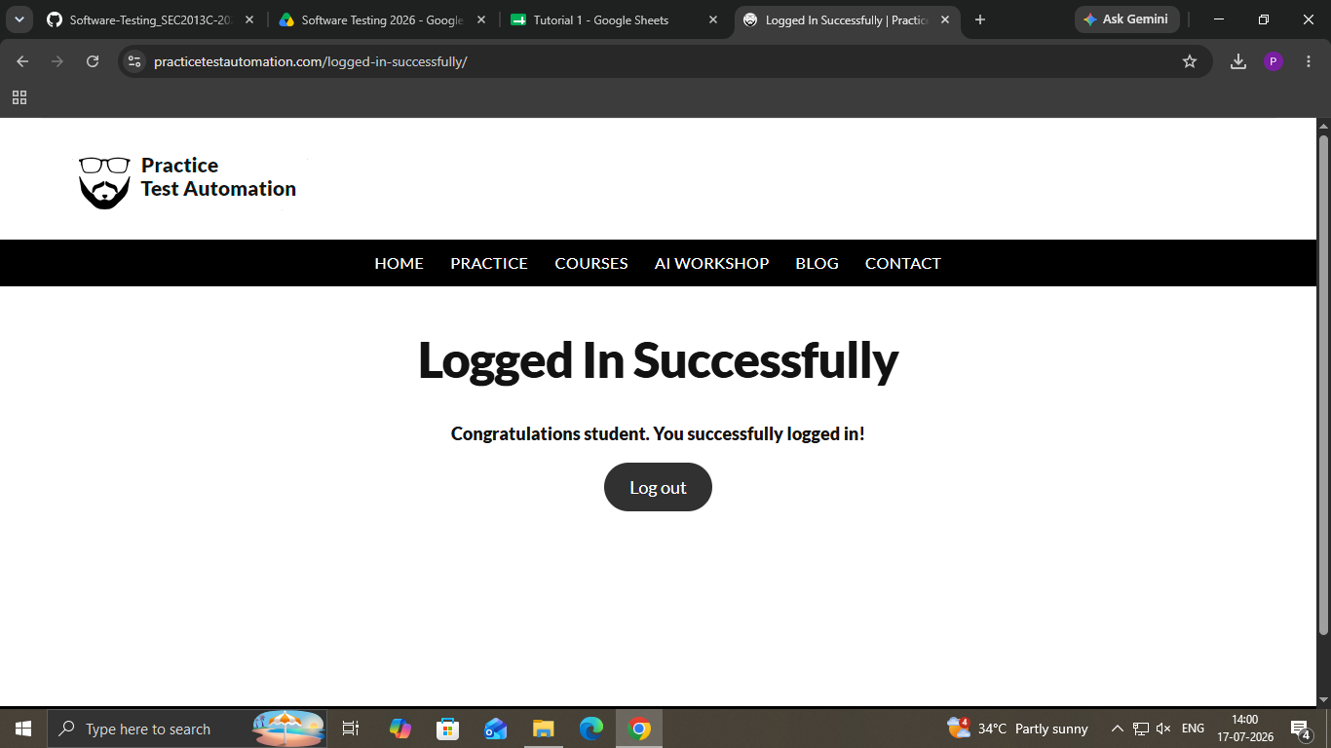

Scenario ID: 2
Scenario: Sign up with invalid credential (Invalid ID, Password)
Test Steps:
1. Open login page
2. Enter username
3. Enter a Password
4. Click on login button

Screenshots: